Sitecoraholics

We have selected “**Sitecore Meetup Website**” idea to demonstrate functionality of website to create meetup events by organizers and end users to register for events.

We have used below modules to implement this functionality.

* SXA 9.3
* Sitecore Forms
* EXM
* Sitecore Forms Extensions (External module from Market place)
* External HTML templates

# Installation Instructions

1. Install Sitecore 9.3 with SXA
2. Download below packages from Github (<https://github.com/Sitecore-Hackathon/2020-SITECORAHOLICS>) root folder and install in order

* Sitecore Forms Extensions for Sitecore 9.3-3.0.zip
* SITECORAHOLICS-1Mar2020.zip
* SitecorAholicsBinariesAndFiles_March2020.zip

1. Go to \App_Config\Sitecore\EmailExperience\Sitecore.EDS.Providers.CustomSMTP.config

And update SMTP details. We have used Gmail account to send emails through EXM.

So, you can use any Gmail username and password.

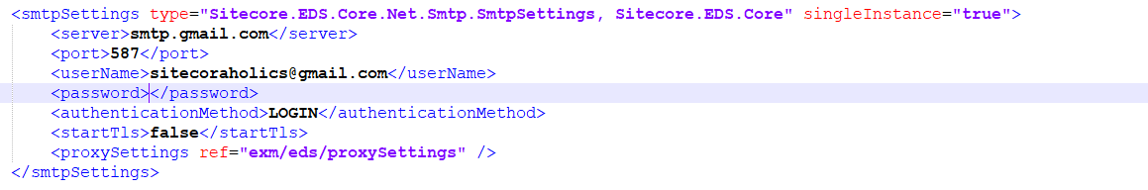

1. Rebuild all indexes from control panel
2. Access Organizer page to verify functionality of creating event
3. Access Event page (/Meetup/SUGCON-India) to check functionality of user registration
4. Verify Email given in registration form

# Screenshots

**Organizer Page- Event Creation**

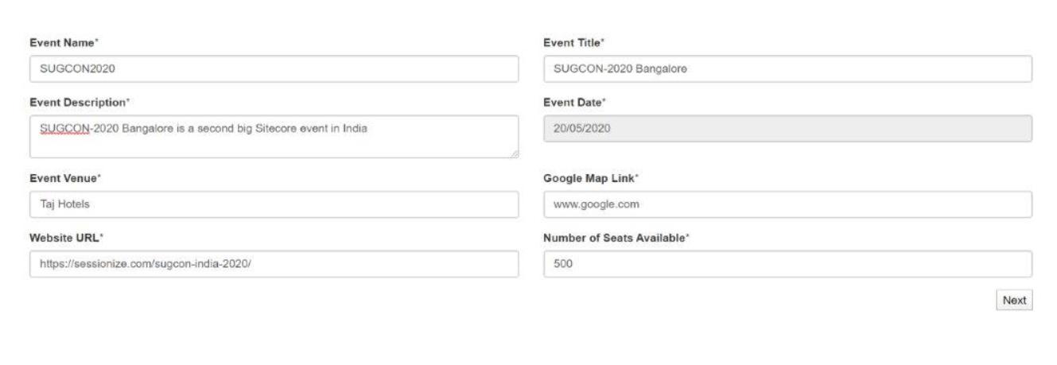

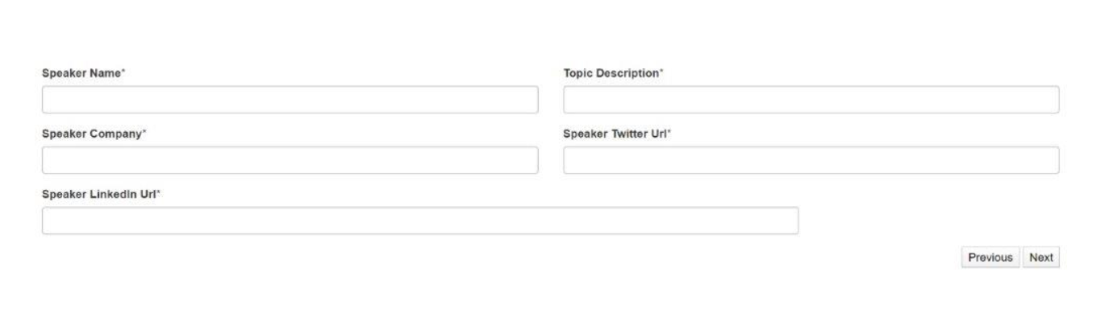

**Event Registration Form**



